To whom it may concern：

As the dean of department of Communication Engineering, I am writing with great pleasure to recommend Mr. Zhongxiang Wu, one of the most outstanding students in the School of Information Engineering, Wuhan University of Technology (WHUT), into your ECE graduate program. As I know, Mr. Wu was selected to enroll Key Class Program of Communication Engineering in WHUT based on his excellent performance on the college entrance examination and our on-campus comprehensive test.

I was acquainted with Mr. Wu for more than one year but came to know him well in his sophomore year, as he enrolled in two of my classes, *Fundamentals of Circuit Analysis*, and *Electromagnetic Field & Electromagnetic Wave*. I always found his books riddled with careful notes that have recorded his endeavor of careful thinking. During office hours, he always asked really challenging questions about the course materials and lab session. Undoubtedly, he was able to achieve a top score in my classes.

In view of Mr. Wu’s excellent performance in academic ability, the Dean of Opening Laboratory, Professor Yuanli Wang, accepted him to her lab for the study and research of B-ISDN combined with ATM and SDH. He was responsible for Load Leveling and network QOS.  During fourth year, Mr. Wu was selected to join the Junior Scholar Exchange Program with Beijing University of Post and Telecommunication (BUPT), which allows our top-tier students to work with world-class faculty in BUPT for an entire academic year.

Through the course of four years of study and research, Mr. Wu demonstrated his passion and talent in academic. He also won the first-class scholarship based on academic ability many times. He ranked No. 2 out of 265 students when graduated from school of Information Engineering, with cumulative GPA 3.82 /4.0.

However, during the contact process with Mr. Wu, I had not found that he had achievements in extracurricular organizations or associations, such as the student union organization, etc. It may be the reason why he spent more time than others on studying, but I do hope that our students can develop their strength in an all-around way.

In short, I believe Mr. Wu’s career goal is a result of careful thinking. Regarding his qualities like his intellect and passion for science, I am very optimistic about his academic future. I strongly recommend him for your program.

Your kind consideration will be highly appreciated!

|  |  |
| --- | --- |
|  |  |
|  |  |

Best Regards,

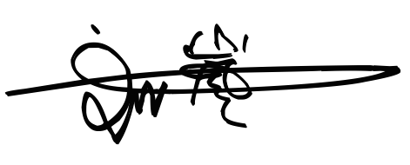

Lan Liu

Professor, Dean, Department of Communication Engineering

School of Information Engineering

Wuhan University of Technology